Baggage lock-up facility
This facility is located in the basement area below the International terminal building. They can be contacted on +27 11 390 2064

Baggage storage
There is a luggage-storage depot on the upper level of the underground parkade, near the main lift lobby in International Arrivals. You may leave any baggage at a cost of R50.00 per item for the first day and R40.00 per item every day thereafter. Mastercard and Visa accepted. Open 24 hours 7 days a week

Official porters have ACSA authorised permits and wear bright orange uniforms.

Tip R5/bag

International Transfer Facility (JIA)
Johannesburg International Airport has a transfer facility which is located in the International Arrivals Hall. This facility is directly on your left-hand side as you enter the Arrivals Terminal. It is for all classes of travel on SAA, but does have a desk exclusive to Platinum Card Holders. This will assist with a trouble-free transfer and retrieval of luggage at your final domestic destination. Once you have checked in here you can collect your boarding card and move through to the Domestic Departures area.

International Arrivals Lounge (JIA)
This facility is for the exclusive use of our First Class, Business Class and Platinum and Gold Cardholders, and offers exceptional facilities, such as luxurious showers, an array of cold breakfast items, and high-tech business equipment. It is located on the Mezzanine level in the Arrivals Terminal. (As you exit the Customs area
it is on the right hand side on the Mezzanine area.)

Baobab Lounge (JIA – Business Class International)
The Baobab lounge is situated on the lower-mezzanine level (airside) of the International Departures Terminal. The lounge offers both business and leisure facilities. There is a streamlined efficiency to the lounge, which boasts, among other facilities, 33 workstations offering ergonomic business modules, computers, printers and faxes.

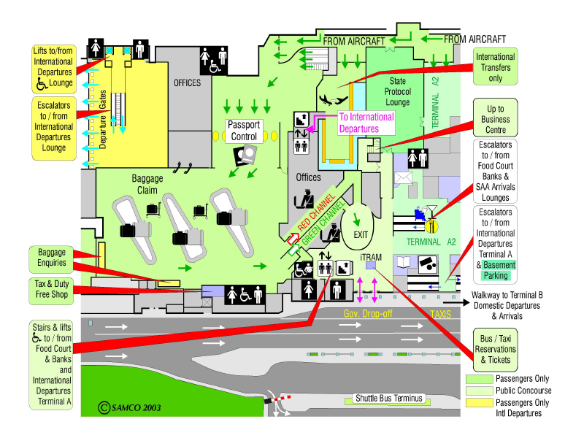
International Arrivals A1I

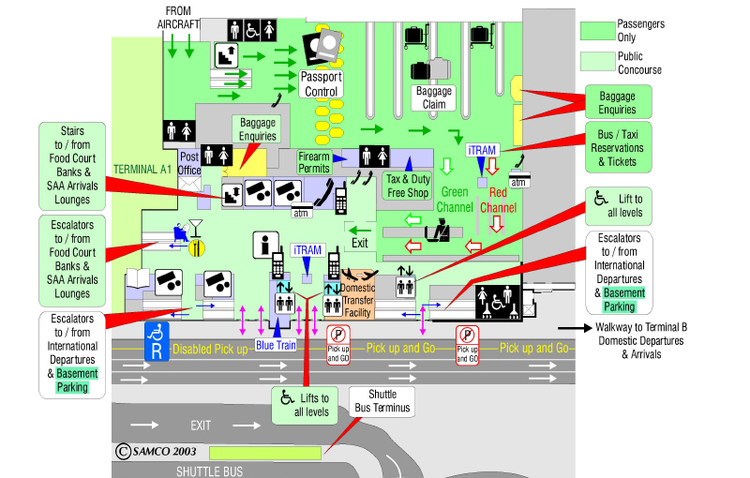
International Arrivals A2I
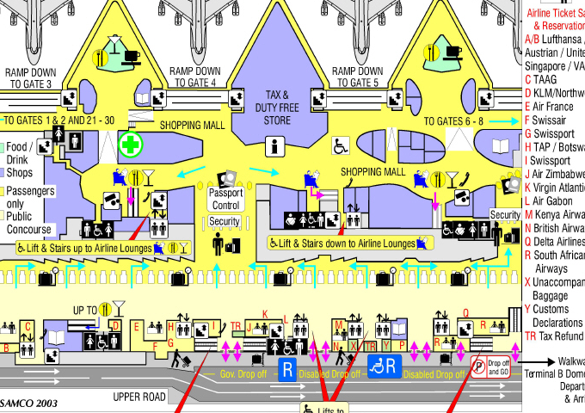
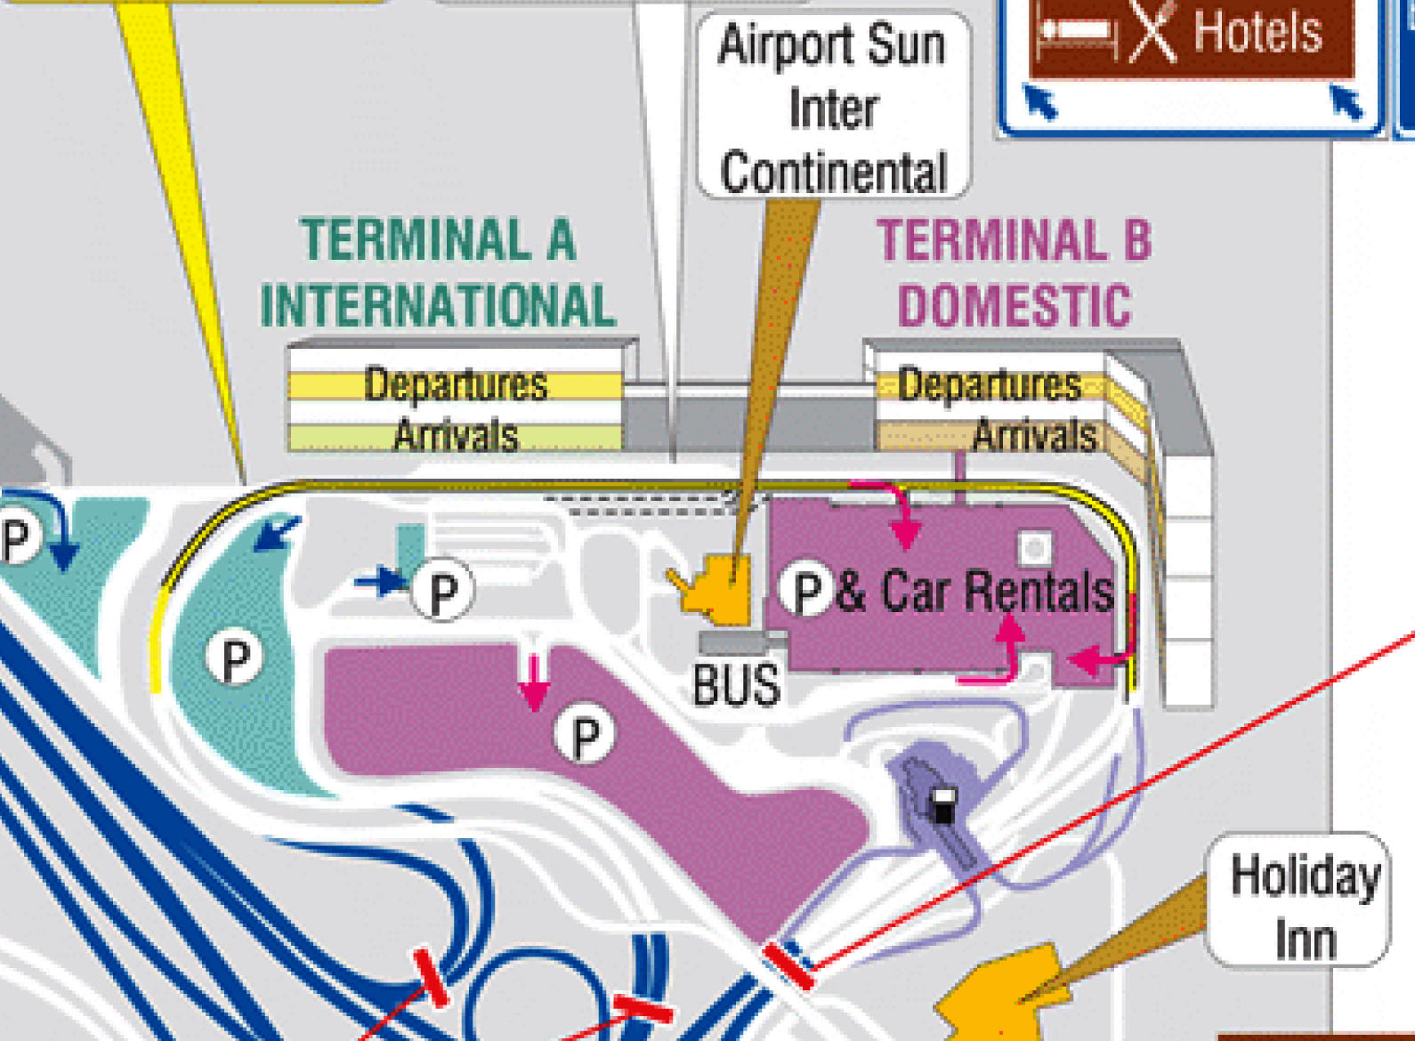
International Departures

